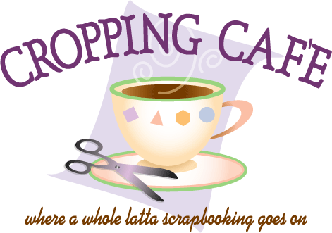

Meeting Since 2005 on Maryland’s Eastern Shore

Lisa Fritts 410 726 1788; [lfwhim@comcast.net](mailto:lfwhim@comcast.net)

[**www.croppingcafe.com**](http://www.croppingcafe.com)

Fb: Cropping Café – A Latta Scrapbooking

Hosted by Church of God of Prophecy

208 Tilghman Road, Salisbury, MD 21804

One Friday and Saturday a month the Cropping Cafe transform the hall at Church of God of Prophecy into a Café of Creativity filled with scrapbooking, friends, fellowship and fun.

* 18 hours of cropping; Friday, 4pm to 12am; Saturday, 9am to 7pm (clean up), Just $20.
* Tool area w/Punches and Cricut. (BYOMat).
* Free Make ‘n Take. Vendors. Classes ($).
* $5 Meals for Fri Dinner & Sat Lunch

**2020 Calendar**

Nov

6&7

No Dec

Sept

11&12

Oct

9&10

July

17&18

Aug

7&8

May

1&2

June

5&6

Mar

13&14

Apr

17&18

Jan

10&11

Feb

21&22

**GUEST SPECIAL**

At your FIRST time to our MONTHLY CROP we would like to give you HALF PRICE ADMISSION FEE.

Meeting Since 2005 on Maryland’s Eastern Shore

Lisa Fritts 410 726 1788; [lfwhim@comcast.net](mailto:lfwhim@comcast.net)

[**www.croppingcafe.com**](http://www.croppingcafe.com)

Fb: Cropping Café – A Latta Scrapbooking

Hosted by Church of God of Prophecy

208 Tilghman Road, Salisbury, MD 21804

One Friday and Saturday a month the Cropping Cafe transform the hall at Church of God of Prophecy into a Café of Creativity filled with scrapbooking, friends, fellowship and fun.

* 18 hours of cropping; Friday, 4pm to 12am; Saturday, 9am to 7pm (clean up), Just $20.
* Tool area w/Punches and Cricut. (BYOMat).
* Free Make ‘n Take. Vendors. Classes ($).
* $5 Meals for Fri Dinner & Sat Lunch

**2020 Calendar**

Nov

6&7

No Dec

Sept

11&12

Oct

9&10

July

17&18

Aug

7&8

May

1&2

June

5&6

Mar

13&14

Apr

17&18

Jan

10&11

Feb

21&22

**GUEST SPECIAL**

At your FIRST time to our MONTHLY CROP we would like to give you HALF PRICE ADMISSION FEE.

Meeting Since 2005 on Maryland’s Eastern Shore

Lisa Fritts 410 726 1788; [lfwhim@comcast.net](mailto:lfwhim@comcast.net)

[**www.croppingcafe.com**](http://www.croppingcafe.com)

Fb: Cropping Café – A Latta Scrapbooking

Hosted by Church of God of Prophecy

208 Tilghman Road, Salisbury, MD 21804

One Friday and Saturday a month the Cropping Cafe transform the hall at Church of God of Prophecy into a Café of Creativity filled with scrapbooking, friends, fellowship and fun.

* 18 hours of cropping; Friday, 4pm to 12am; Saturday, 9am to 7pm (clean up), Just $20.
* Tool area w/Punches and Cricut. (BYOMat).
* Free Make ‘n Take. Vendors. Classes ($).
* $5 Meals for Fri Dinner & Sat Lunch

**2020 Calendar**

Nov

6&7

No Dec

Sept

11&12

Oct

9&10

July

17&18

Aug

7&8

May

1&2

June

5&6

Mar

13&14

Apr

17&18

Jan

10&11

Feb

21&22

**GUEST SPECIAL**

At your FIRST time to our MONTHLY CROP we would like to give you HALF PRICE ADMISSION FEE.